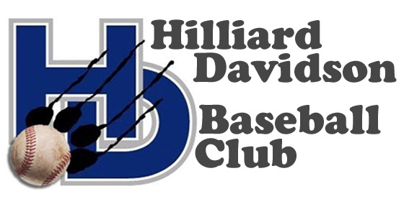

Dear Sponsor:

My son SON’S NAME plays baseball for Hilliard Davidson and I am helping with a fundraising campaign for an indoor hitting facility. We are seeking outfield banner sponsorships for our home field (at Davidson/Avery Roads) in the form of $500 contributions for a 3’x 6’ banner featuring your logo/website/phone (design is up to you). Games begin in March and last through May with 3-5 games per week. Summer and fall leagues pick up after the school season resulting in a total of 50-75 games per season. The banner seems like a great advertising opportunity with a captive audience and we will purchase and hang the banner!

The Hilliard Davidson and Weaver Baseball Teams are part of the Ohio Capital Conference and include young athletes in grades 7-12 who have demonstrated their ability to compete at a high level. These teams were developed to compete with other local and state baseball teams representing their school and community. The primary function of our organization is to generate funding for improvements and equipment to support an environment for the athletes to improve their skills, challenge themselves, and encourage teamwork.

The teams have been working in the off-season on strength and conditioning as well as assisting with a baseball camp for Hilliard youngsters. Since our organization also benefits the baseball program at Hilliard Weaver Middle School, we support over 100 athletes. It is always expected that our teams will represent themselves and the Community of Hilliard in a positive manner.

The Hilliard Davidson Baseball Club is a public charity, Tax Identification number
35-2472610.The purpose of this communication is to ask your thoughtful consideration in supporting such a worthwhile and positive youth activity. Should you decide to become a sponsor, your business will receive special recognition at our Meet the Team event held on March 18, 2019, as well as on our club’s website. Banner sponsorships must be confirmed by on or before March 9 to be ready for the upcoming season.

If you have any questions concerning this event, please feel free to contact YOUR NAME at (###) ##-####, or EMAIL ADDRESS. You may address your tax-deductible donation to:
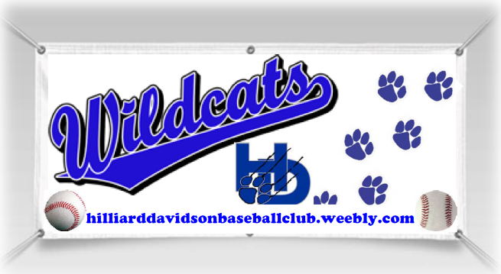
Hilliard Davidson Baseball Club
C/O YOUR NAME
YOUR ADDRESS
Hilliard, OH 43026

Thank you for your consideration and generosity,
Hilliard Davidson Baseball Club Board

Hilliard Davidson Baseball Club
www.hilliarddavidsonbaseballclub.weebly.com

