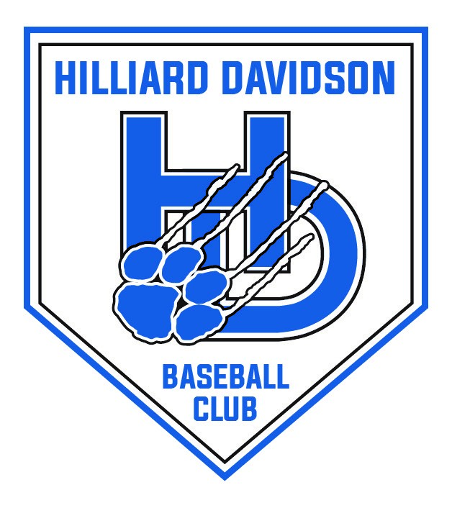
Hilliard Davidson Baseball Parent Club
Scholarship Committee
Hilliard Davidson High School
5100 Davidson Road
Hilliard, OH 43026

January 7, 2023

Dear Scholarship Applicant,

Thank you for your interest in the Hilliard Davidson Baseball Parent Club Scholarship Program. We are delighted to announce that this year our Parent Club will make available a grand total of $2,000 for individual scholarship awards. Award amounts will depend on the number of qualifying applicants. You may apply for any one of our three types of scholarships: (1) General Baseball Scholarship, (2) Academic Baseball Scholarship and (3) Play at the Next Level Scholarship.

Please review the enclosed Application Materials consisting of the Scholarship Guidelines, the Application Process, and the Application Form. All applications are due to the Hilliard Davidson Guidance Office by 3:00 pm Friday, March 17, 2023. No late or incomplete applications will be accepted! Feel free to contact Gayle Friedman at 614-921-7216 with any questions.

We congratulate you, your hard work, and dedication with your academic and baseball career at Hilliard Davidson High School. We wish you much success with your future endeavors!

Sincerely,

Christopher Conrad and Eric Endres
Hilliard Davidson Baseball Parent Club
2023 Scholarship Committee Co-Chair

Hilliard Davidson Baseball Parent Club
2023 Scholarship Guidelines:

(A grand total of $2,000 will be available for individual scholarship awards to select graduating senior baseball athletes under three scholarship categories. Please note that award amounts will be determined by the number of qualifying applicants)

1. Athlete must have participated in the Baseball Program at Hilliard Davidson High School for at least three years, one of which must be his senior year.

2. Athlete must have a minimum G.P.A of 3.0 for General Baseball Scholarship and Playing at the Next Level Scholarship. A G.P.A. of 3.75 is required for the Academic Baseball Scholarship.

3. Athlete must be committed to play baseball at a college or university for the Playing at the Next Level Scholarship.

4. Athlete must be in “Good Standing” with Baseball Parent Club Organization, having paid all fees, participated in fundraising, and returned all uniforms.

5. Athlete must have good character as displayed by his commitment to his team, school, and community.

6. Athlete must complete an Application Form and write a one-page essay on a separate sheet of paper detailing a high school baseball experience that added to your appreciation for the sport of Baseball, and/or teammates, and/or coaches. Essay must be typed and double spaced – no handwritten essays will be accepted.

7. Athlete must submit two letters of recommendation, one from a coach and another from a teacher, counselor, or community leader, in support of athlete’s “Good Standing.” These letters must support the athlete’s good character and be typed and signed by their author.

8. Athlete must submit a Completed Application Packet consisting of: (1) an application form, (2) a one-page typed essay, (3) two letters of recommendation and (4) signed verification, to the Hilliard Davidson Guidance Office no later than 3:00 pm, Friday, March 17, 2023. It is the applicant’s responsibility to turn in an Application Packet for consideration.

9. Athlete can check more than one box on the application form for consideration for multiple Scholarship categories. Please note that applicants are limited to receiving ONE Baseball Scholarship.

10. The scholarship committee may select more than one awardee for any given scholarship category and is not required to select an awardee in each category.

Hilliard Davidson Baseball Parent Club
2023 Scholarship Application Process:

Eligible Senior Baseball Athletes may pick up scholarship application forms in the Hilliard Davidson Guidance Office.

All forms must be returned to the Guidance Office by 3:00 pm, Friday, March 17, 2023. Applicant is responsible for turning in: Application Form, Essay, and two letters of recommendation. Late or incomplete documents will not be considered.

The Baseball Parent Club has delegated review authority to the Scholarship Selection Committee to review Completed Applications. The Selection Committee is made up of six baseball club parents unrelated to players (two from 9th, 10th, and 11th grades and representing all three teams).

Baseball Scholarship winner(s) will be notified prior to the Scholarship Awards Program on Wednesday, April 26, 2023 at 8:00 am and will be invited to the program to be recognized.

Scholarship(s) will be granted to the winner(s) following verification of acceptance and enrollment deposit at an accredited College or University. Funds must be returned to Hilliard Davidson Baseball Parent club, in full, should the athlete not attend an accredited College or University or receives other financial aid that prohibits him from receiving this award.

Verification and Signatures
I, the applicant, will submit my application, essay, two letters of recommendation to the Hilliard Davidson Guidance Office by 3:00 pm, Friday, March 17, 2023.
I have answered all of the questions in this application to the best of my knowledge.
I understand that the Hilliard Davidson Athletic Department and/or the Hilliard Davidson Guidance Office will verify that I have participated in the Baseball program for three years, including my senior year, and that I have met the required GPA.

All above items are verified as part of the application process.

Signature of Applicant__________________________________ Date __________

Signature of Parent(s) __________________________________ Date __________

__________________________________ Date __________

Hilliard Davidson Baseball Parent Club
2023 Scholarship Application Form

Date: __________________________
Personal Information:

Name: ______________________________________________________________________________________________________________

Address: ___________________________________________________________________________________________________________
______________________________________________________________________________________________________________________

Phone: ( ) - Email _______________________________________________________________________

Please check appropriate box of scholarship you are applying: (Applicants may check more than one box to apply for multiple scholarships, but applicants are limited to one Baseball Scholarship.)

- General Baseball Scholarship
- Academic Baseball Scholarship
- Playing at the Next Level Baseball Scholarship
College or University at which I’m committed to play:___________________________________________________

I participated in at least three years of High School Baseball (including senior year) Y or N
I’ve included a one-page type-written essay (see Scholarship Guidelines) Y or N
I’ve included two letters of recommendation (see Scholarship Guidelines) Y or N
I’ve included a signed verification statement (see Application Process) Y or N

GPA: ____________________

Honors or Awards received in High School Baseball: ____________________________________________________________
_________________________________________________________________________________________________________________________
_________________________________________________________________________________________________________________________

Athletic, Social and Community Activities:

Activity | Honors/Awards/Office Held | Date

