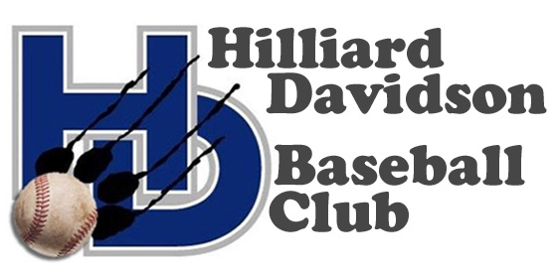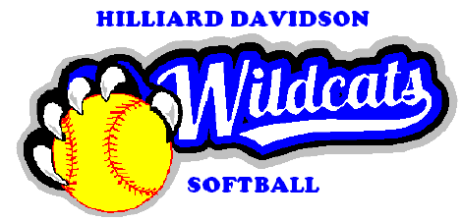

Dear Sir/ Madam:

The Hilliard Davidson baseball and softball programs consist of student athletes in grades 7-12 who have demonstrated an ability to compete at a high level. These teams represent their school and community by competing with other local and state teams. The teams are part of the Central Division of the OSHAA Ohio Capital Conference. These young men and women have been working in the off-season on strength and conditioning.

There are many costs associated with each team ranging from 7th grade through the Varsity level. The athletes pay a fee to participate as a member of the team, however, there are additional expenses associated with improvements. The primary function of this organization is to support an environment for student athletes to improve their skills and challenge themselves, encourage teamwork, and generate funding to assist in improvements for the programs and facilities.

The baseball/softball clubs will be hosting a Night At The Races event on February 8th, 2020. The $25 event is open to families, friends and members of the community and will include a pasta dinner buffet, complimentary brew and beverages as well as opportunities to bet on horse races (information on our website).

We ask that you to consider a $50 sponsorship in the form of check, gift certificate or other form of goods or services from your establishment to become a race book sponsor. We will provide race book advertising for all our sponsors.

Hilliard Davidson Baseball Club is a not-for-profit, Tax Identification #35-2472610. The purpose of this communication is to ask your thoughtful consideration in supporting such a worthwhile and positive youth activity. Should you decide to participate, and your donation is valued at $50.00 or more, your business will receive recognition at our event as well as advertising in our race book. Please confirm your contribution type and amount on or before January 20, 2020.

If you have any questions concerning this event, please feel free to contact Ari Altman at (614) 560-6072, or ari.altman@huntington.com. You may address any donation to:

Hilliard Davidson Baseball Club
C/O Ari Altman, President
3432 River Narrows Road
Hilliard, OH 43026

Thank you for your consideration and generosity,
Hilliard Davidson Baseball and Softball Club Boards

Hilliard Davidson Baseball Club
www.hilliarddavidsonbaseballclub.weebly.com

